1. **TASK 1**

**First Program in C**

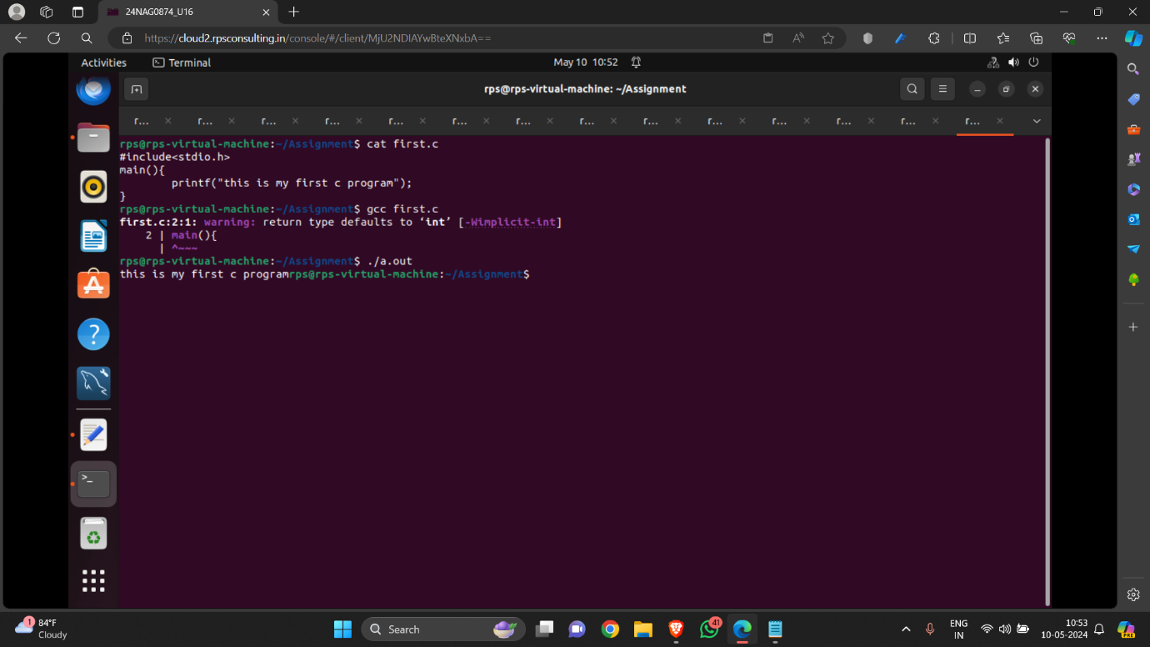

1. **TASK 2**

**Add two numbers**

**Static input**

**Dynamic input**

* **Static input**

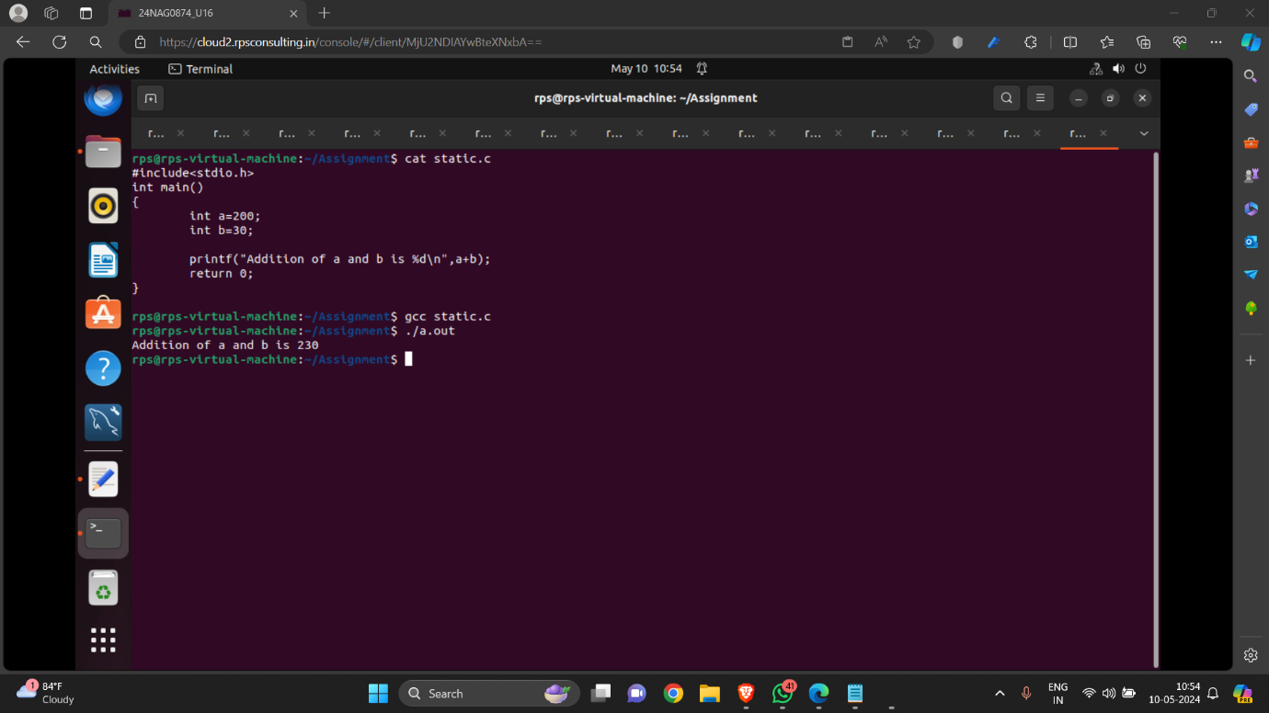

* **Dynamic input**

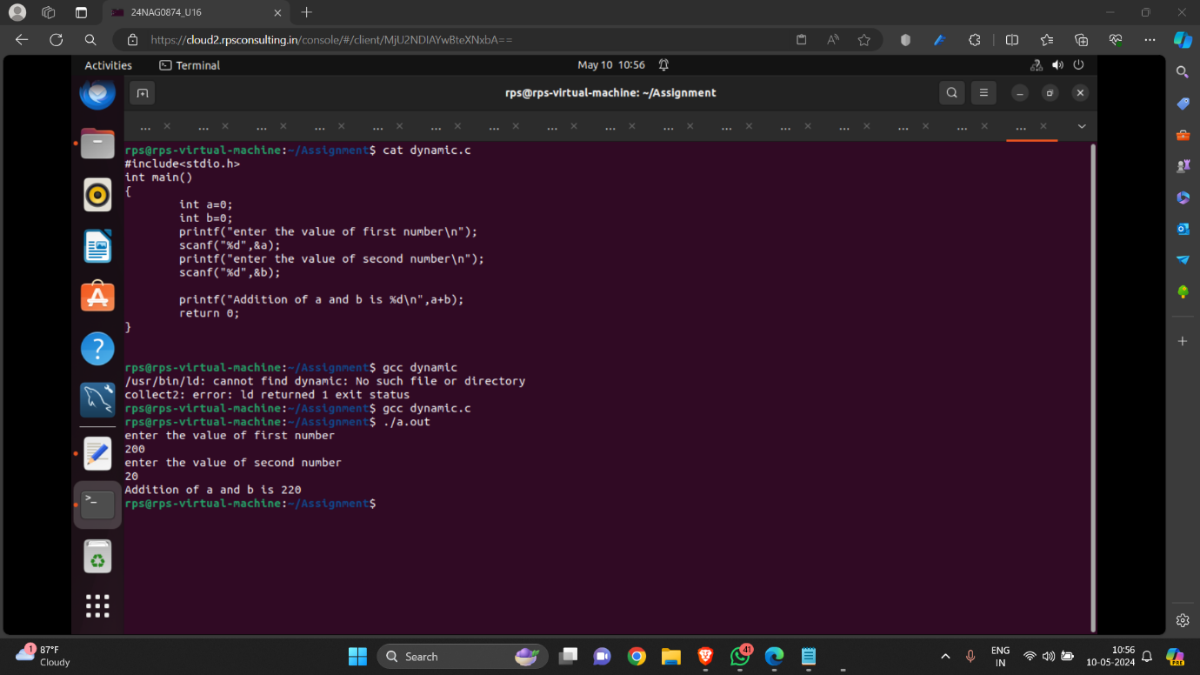

1. **TASK 3**

**Date and Time print on screen**

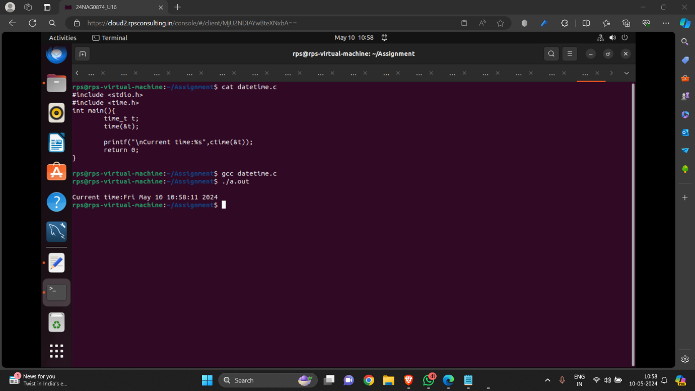

1. **TASK 4**

**Take input from User to enter their name, and on the screen**

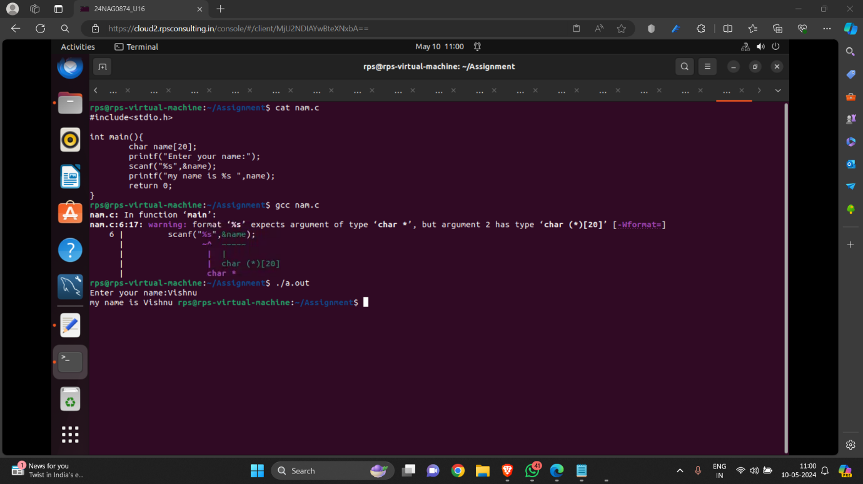

1. **TASK 5**

**Odd or Even number**

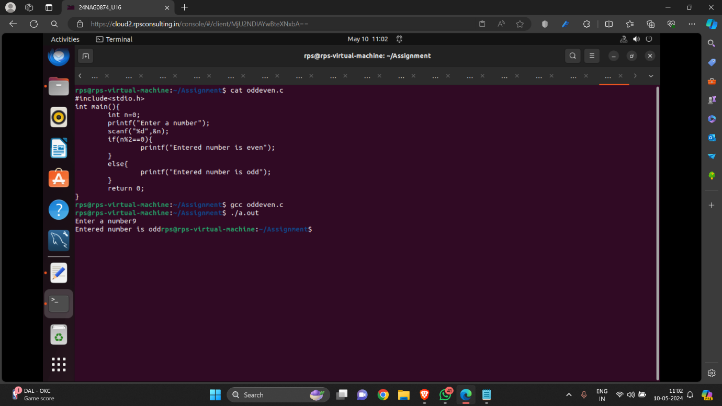

1. **TASK 6**

**ASCII value of a character**

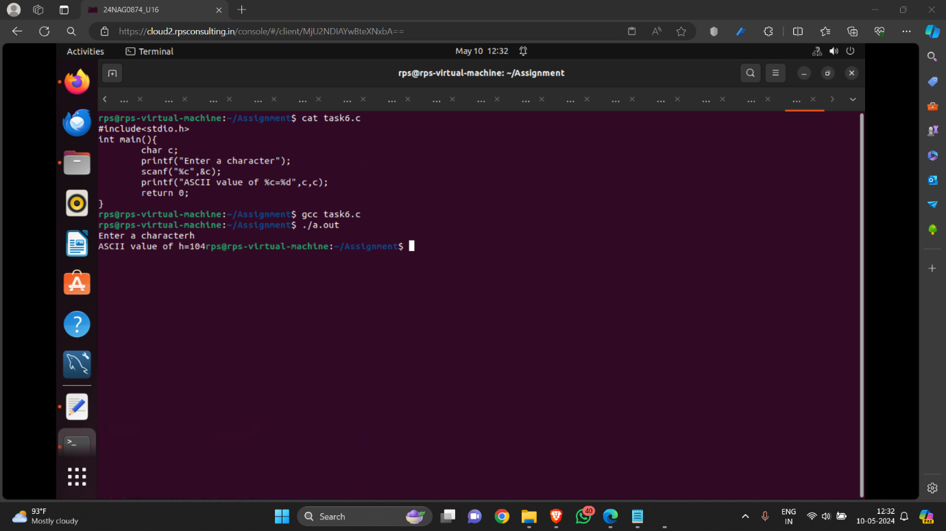

1. **TASK 7**

**Find quotient and reminder**

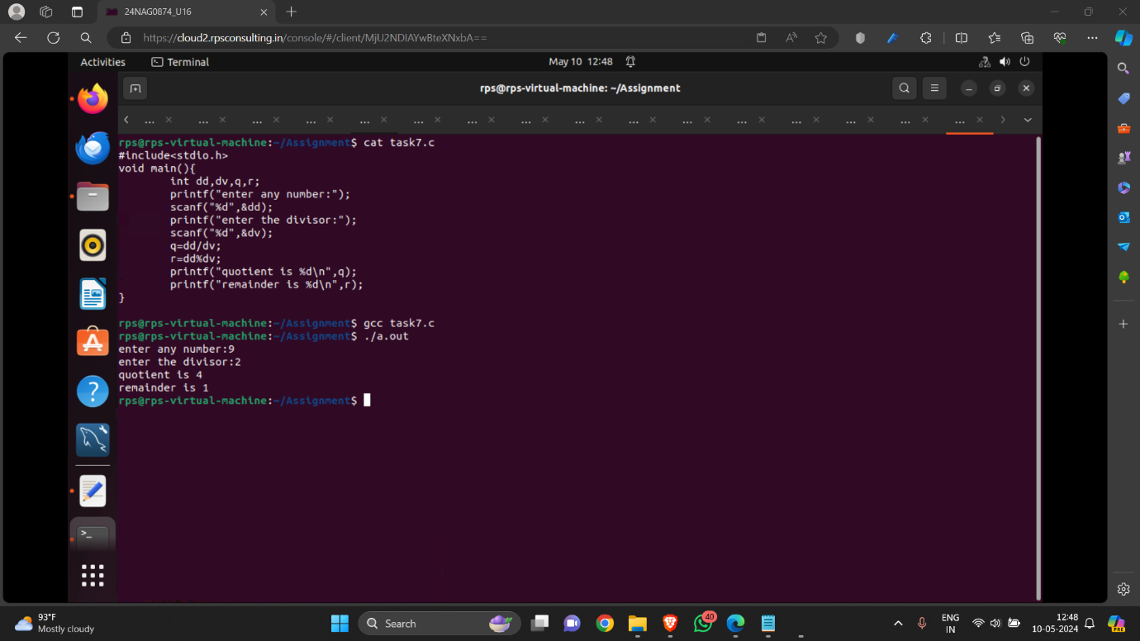

1. **TASK 8**

**Reverse a number**

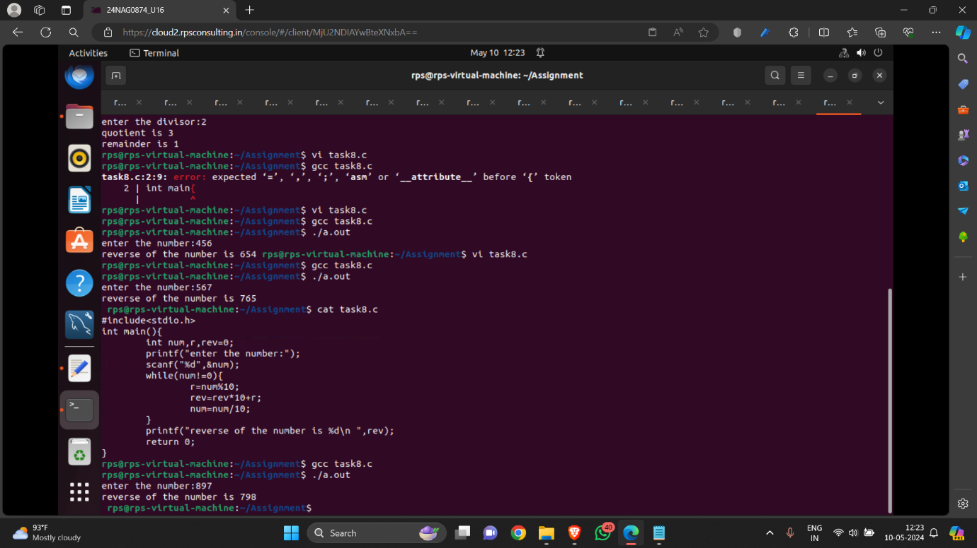

1. **TASK 9**

**Size of data types**

